**1). Heroku Deployment**

- First install Heroku cli as per your system compatibility: https://devcenter.heroku.com/articles/heroku-cli

- Create a heroku account.

- Will push our project in github.

- Create a new repository in github.Open you cmd, be in your project folder first then run the below commands:

- git init

- git add .

- git commit -m "first commit"

- git branch -M main

- git remote add origin 'your own .git' file(like this git remote add origin https://github.com/vikash130795/era.git)

- git push -u origin main

In last command, it'll ask for token.

- On right-hand side at the top, you'll get your profile in which you'll get 'Settings' option.

- After clicking on 'Settings', it will redirect us to next page. On the left-hand side at bottom 'Developer settings' is there.

- Then, select 'Personal access tokens' in which you can 'Generate new token'.

- Place the generated token in the last command option, your project would be pushed in your github repository.

- Check in your cmd heroku is installed or not by this command, 'heroku'.

- If its available then, do login in heroku using this command 'heroku login'.

- Be in your project folder and run this command 'heroku git:remote -a <your appname>'

- Then, push your code with this command 'git push heroku master'

- Now, your app is successfully deployed in heroku.

**2). AWS**

Search for the ‘AWS console’ in google, and select the first link, then do sign up first.

Then look for the ‘Elastic Beanstalk’ service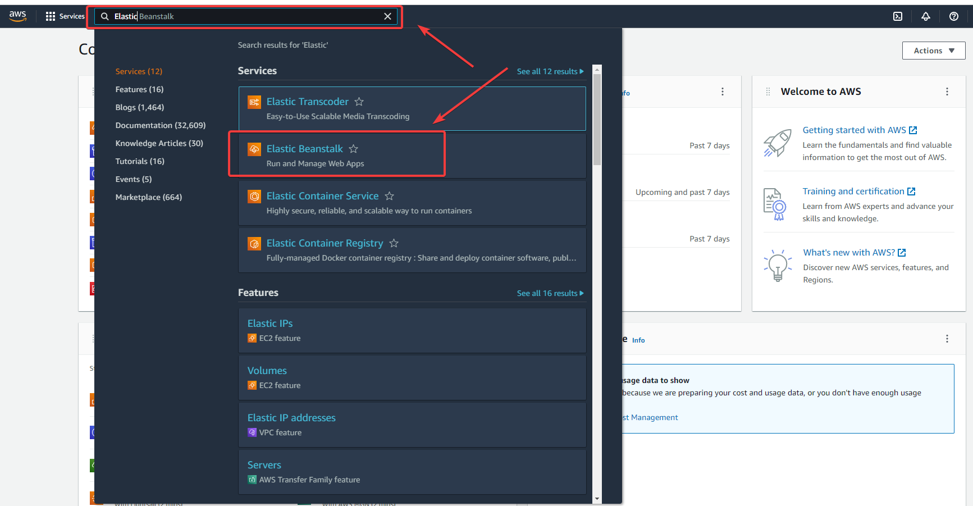

Select ‘Elastic Beanstalk’, it’ll redirect you to the next page. Then, select ‘Create Application’.

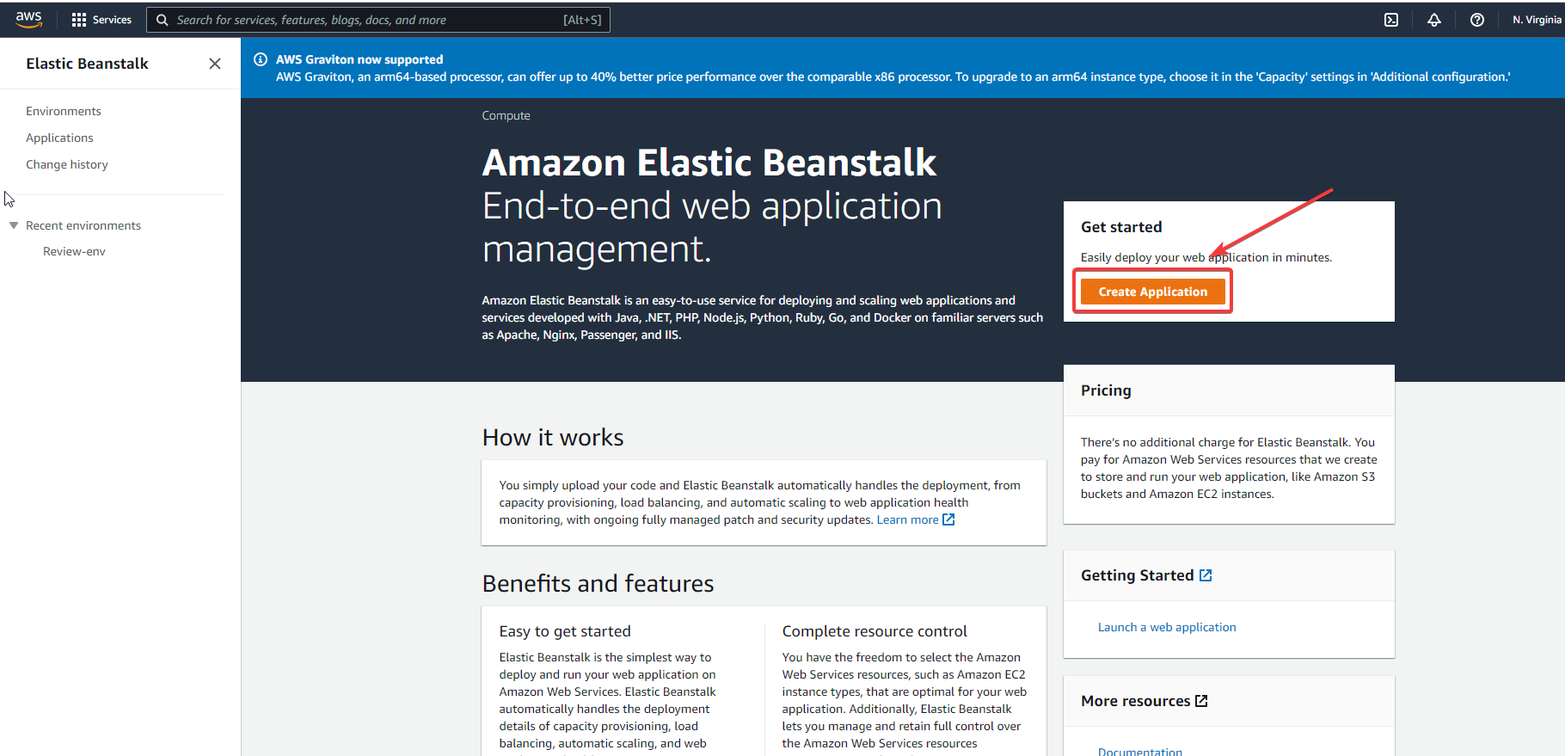

Fill the required details in there, like ‘Application name’, ‘Platform’, choose Python 3.7 here. At last, we can ‘Create application’.

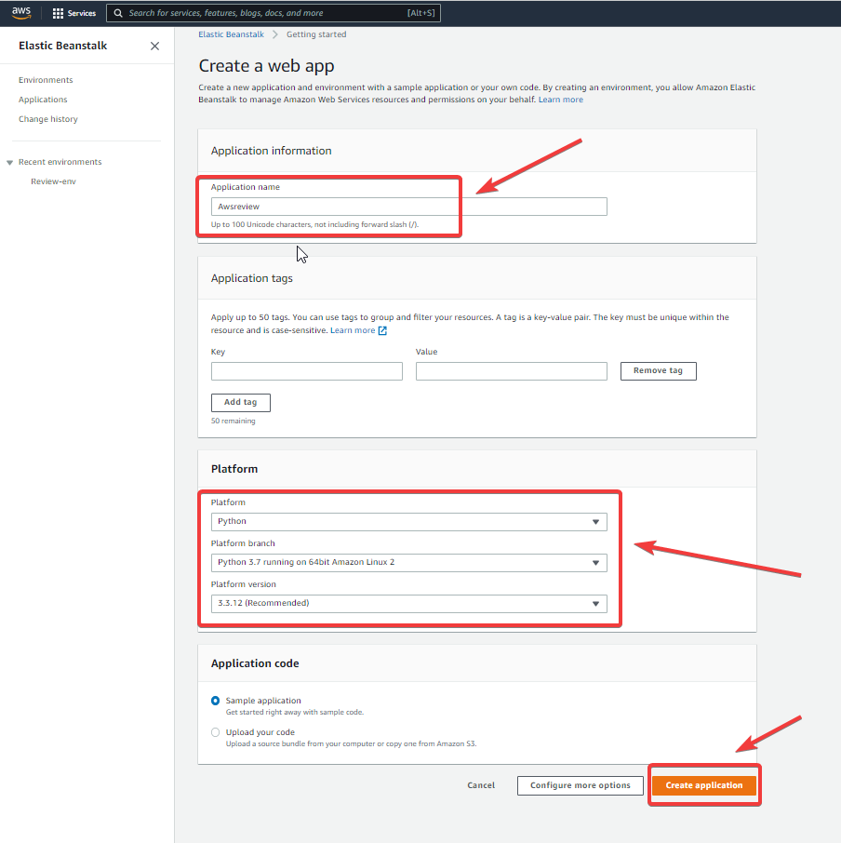

After that, it’ll start creating a new environment.

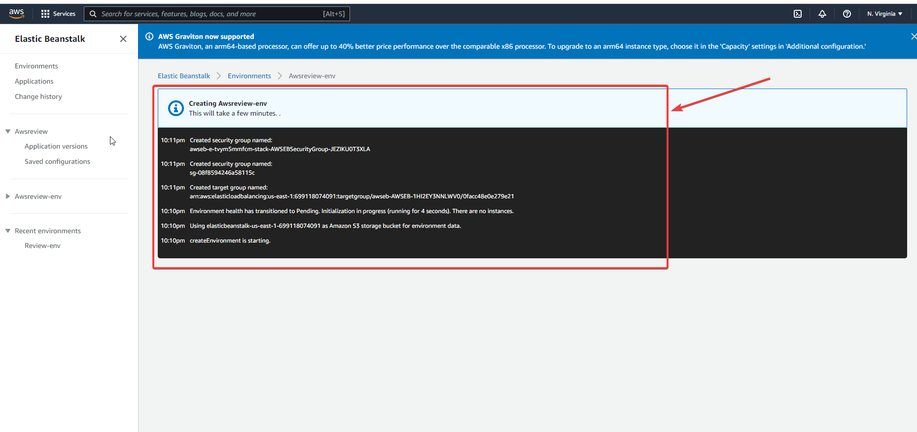

Let it be completed, will now create a pipeline. Open a new tab and search for ‘Code Pipeline’ service in AWS console.

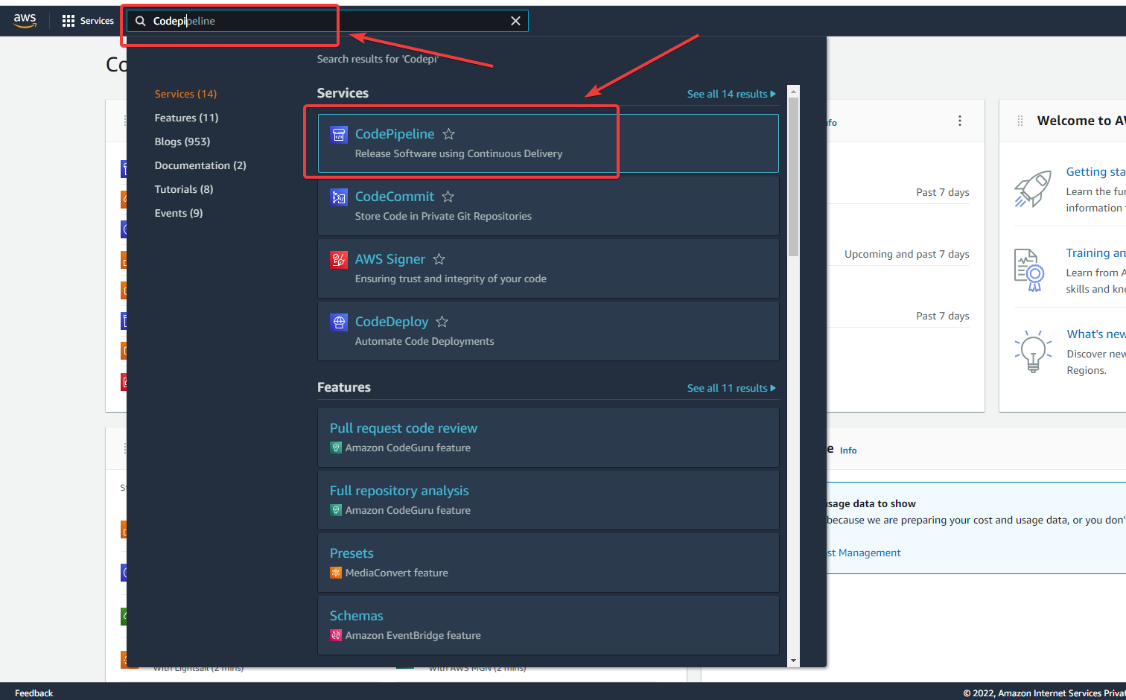

Now, create a pipeline with ‘Create pipeline’

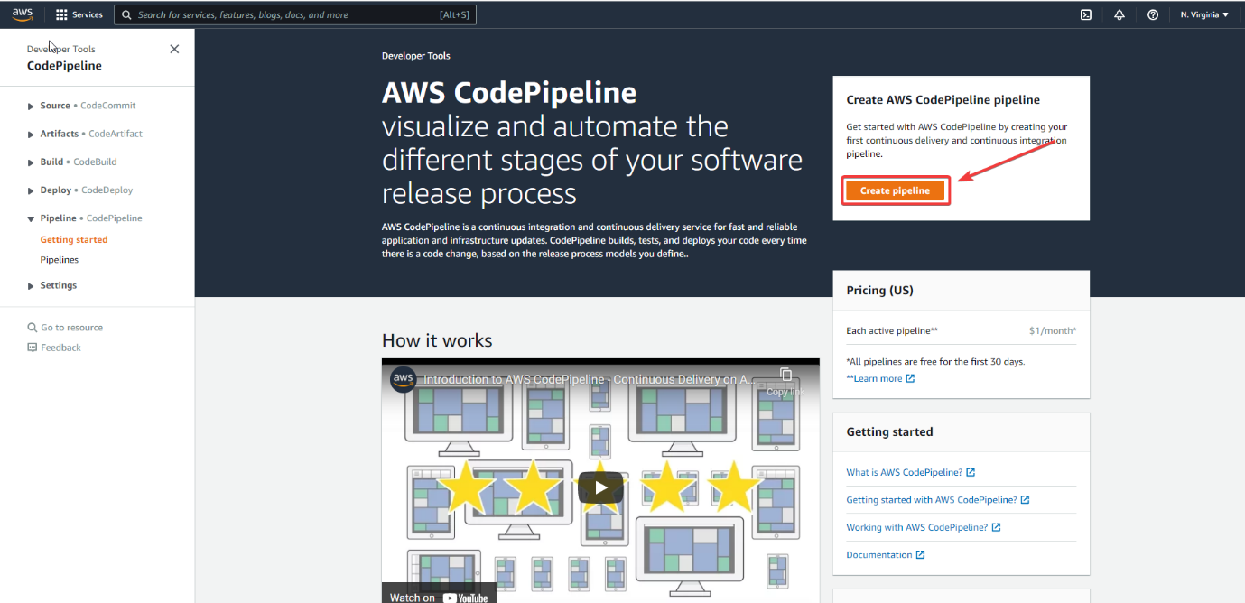

Pick your pipeline name in here like I have given ‘awsrev’. Then click on ‘Next’

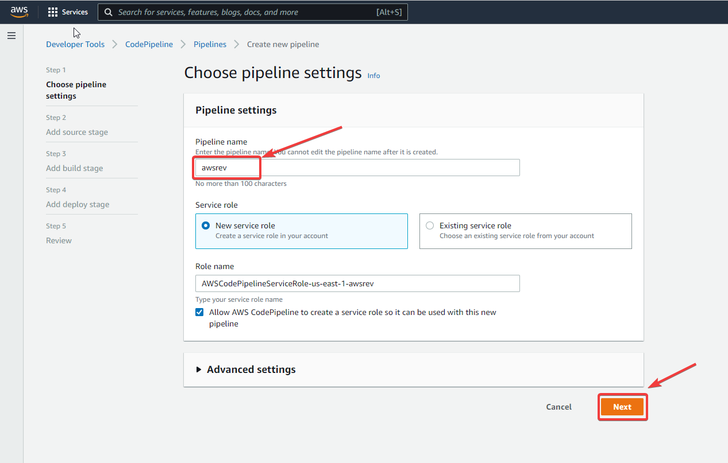

In the next step, Select ‘GitHub(Version 2)’, then select ‘Connect to Github’, one pop-up will open in which, you have to add your ‘Connection name’ and then connect your github.

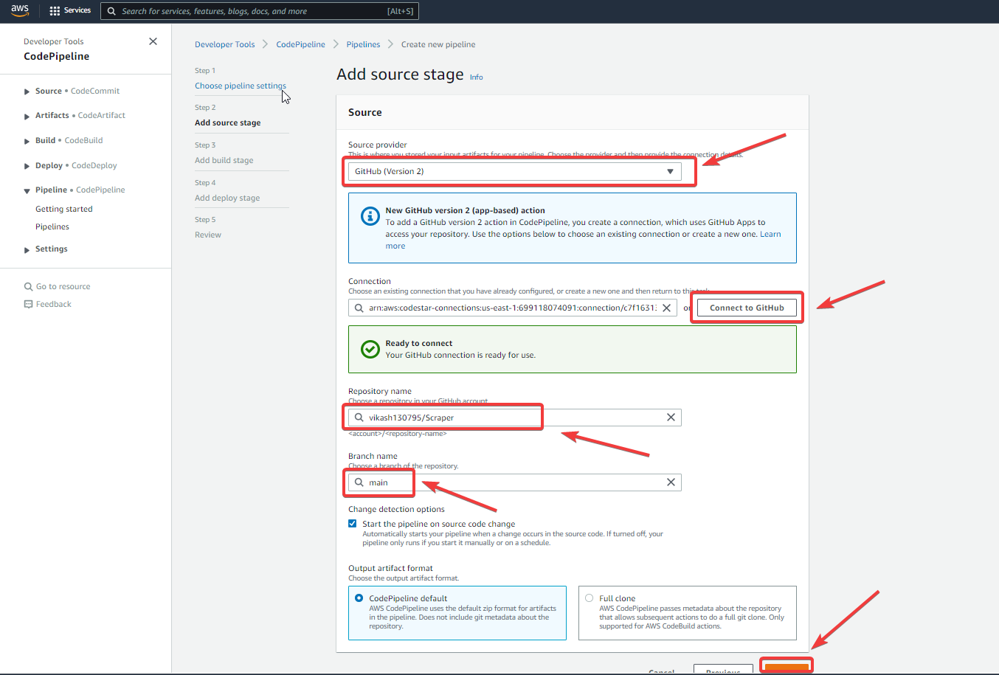

Then, click on ‘Next’ for next steps.

We need to skip this Build stage.

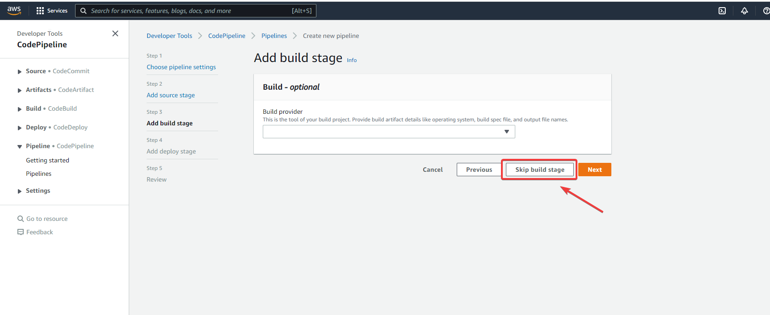

In this step, we need to select the ‘Deploy provider’ as ‘AWS Elastic Beanstalk’ and then add ‘Application name’ which we had created in Elastic beanstalk. Now, move for the ‘Next’ step.

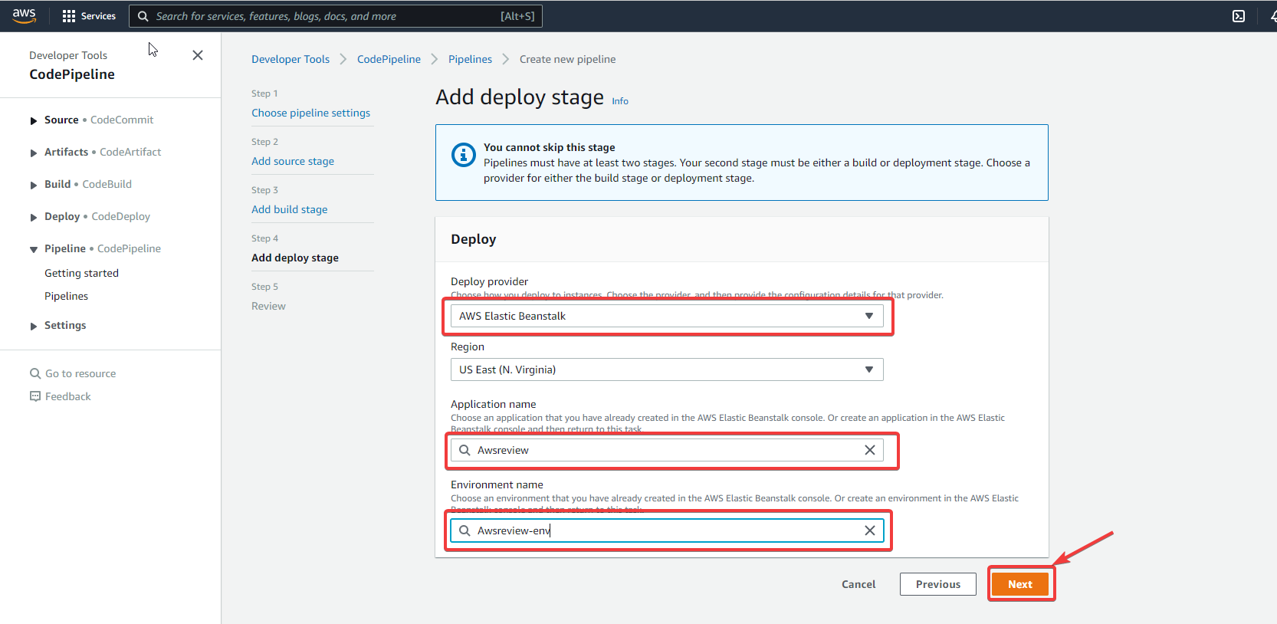

In the next step, it’ll review it and start deploying your app.

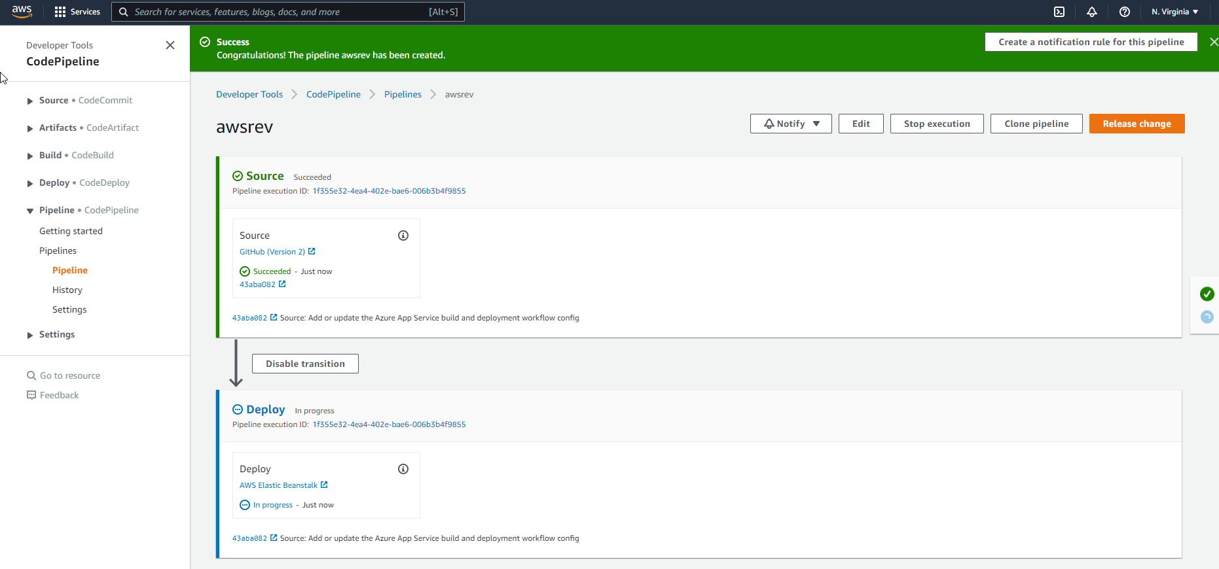

Now, move to your “Elastic Beanstalk” select your app name and select the link for checking your app is deployed or not.

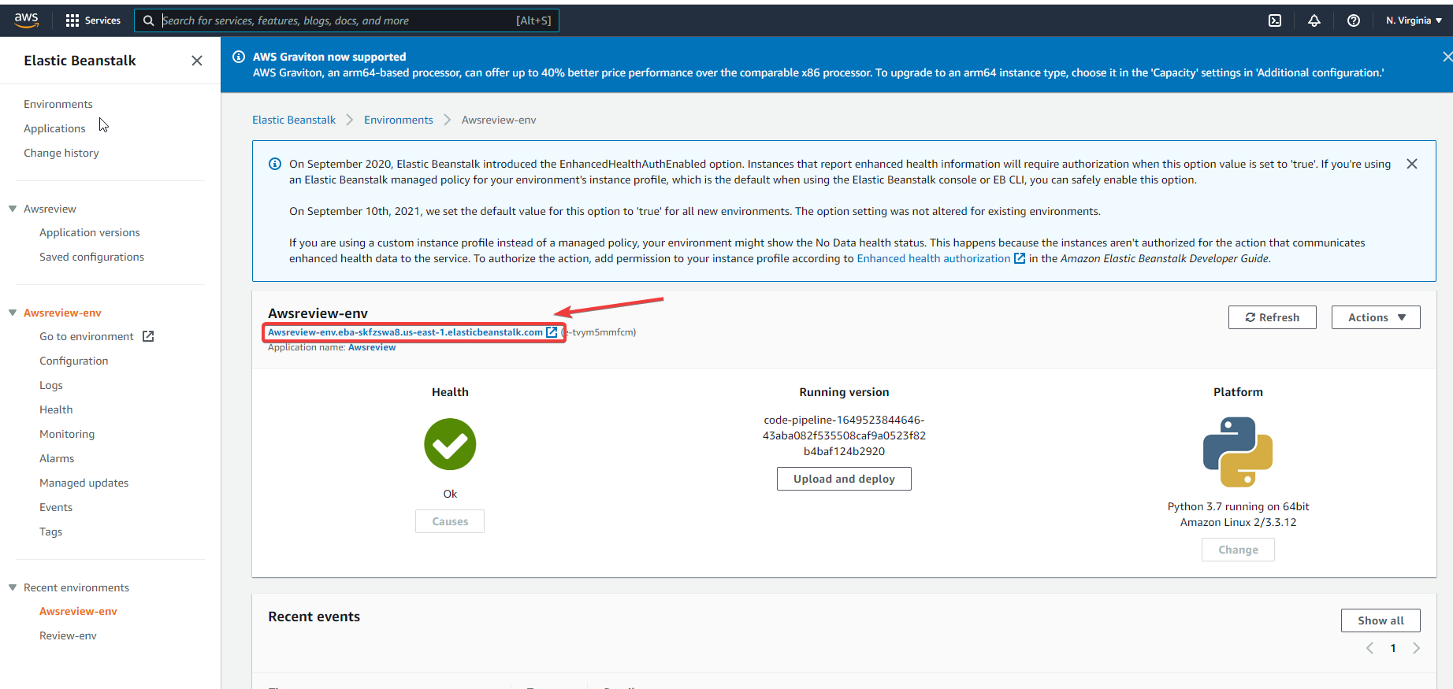

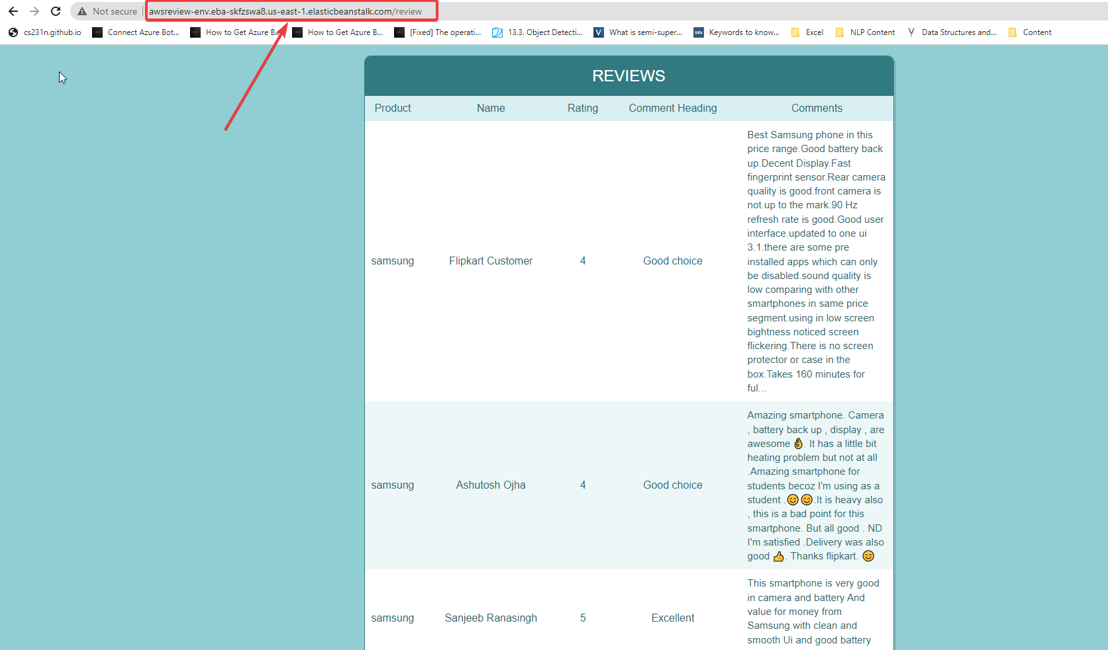

It’s working perfectly fine in here.

**3). Azure**

Search for ‘Azure portal’ in google, then select the second link and do ‘sign in’. You’ll get the below interface. We need to select the ‘Create a resource’ option.

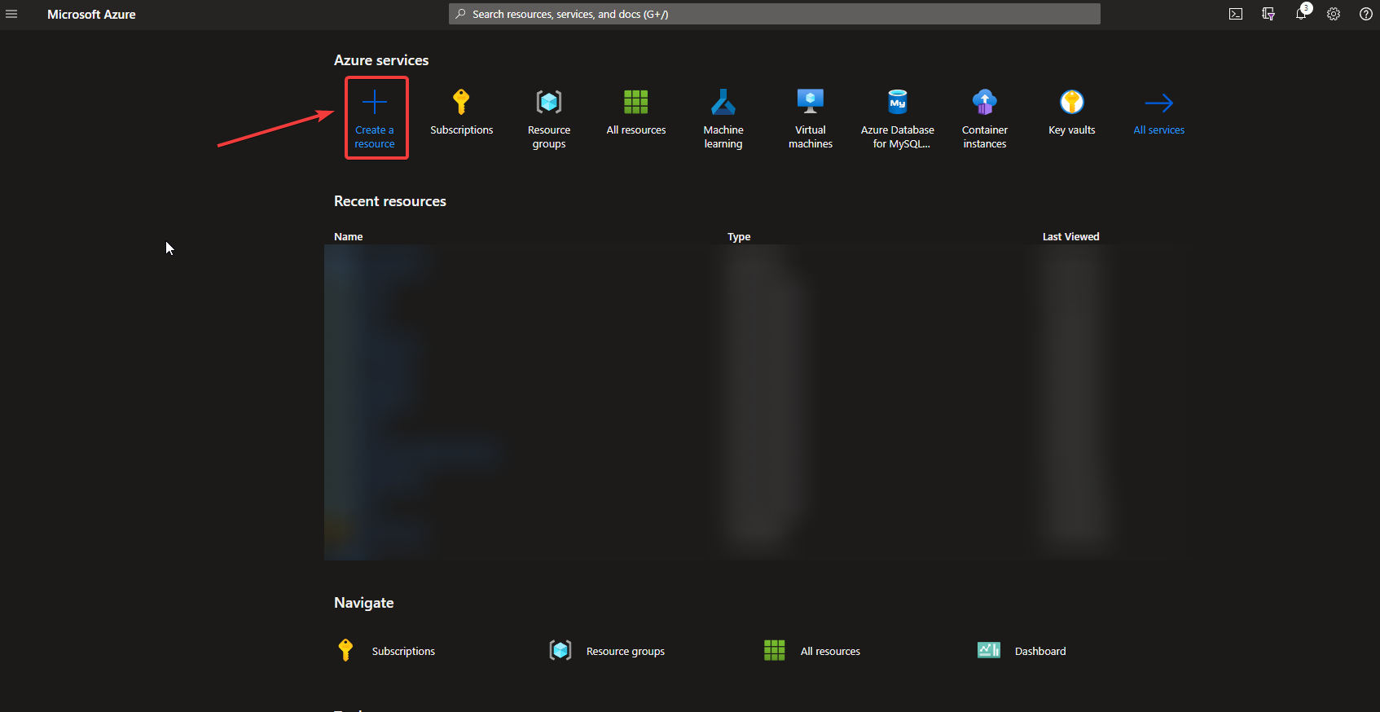

Now, search for the ‘Web app’ here.

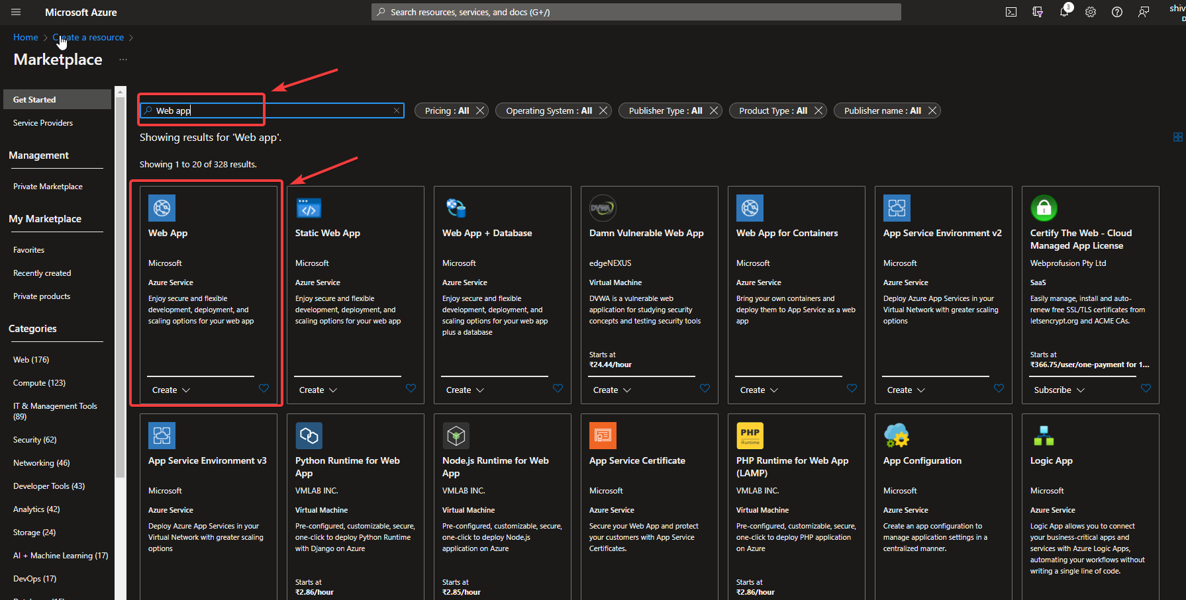

Next, add the required details here. Then, select ‘Review+create’.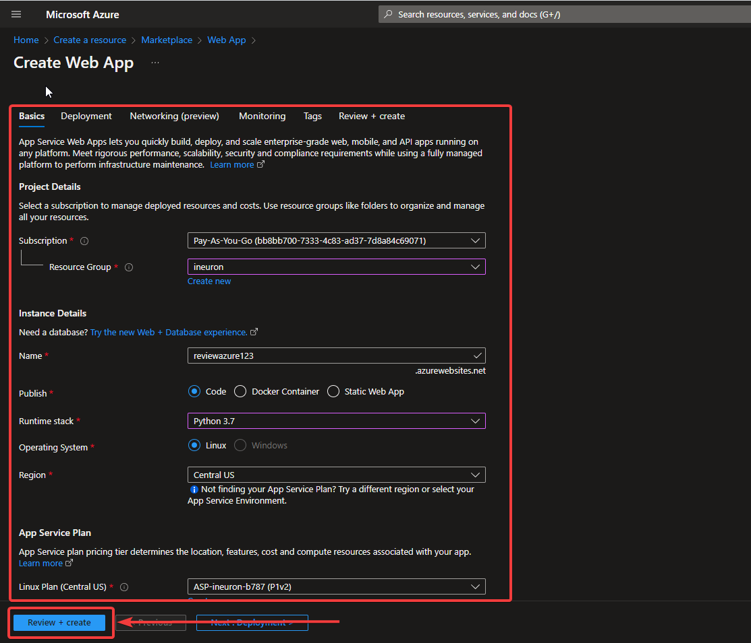

Then, choose the ‘Create’ option here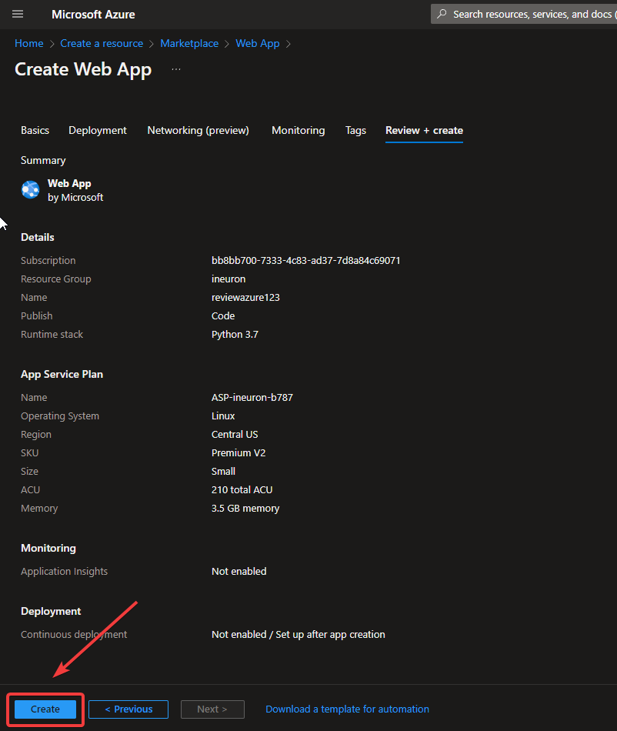

It’ll start deploying your app. If it is done, it’ll show ‘Go to resource’ option.

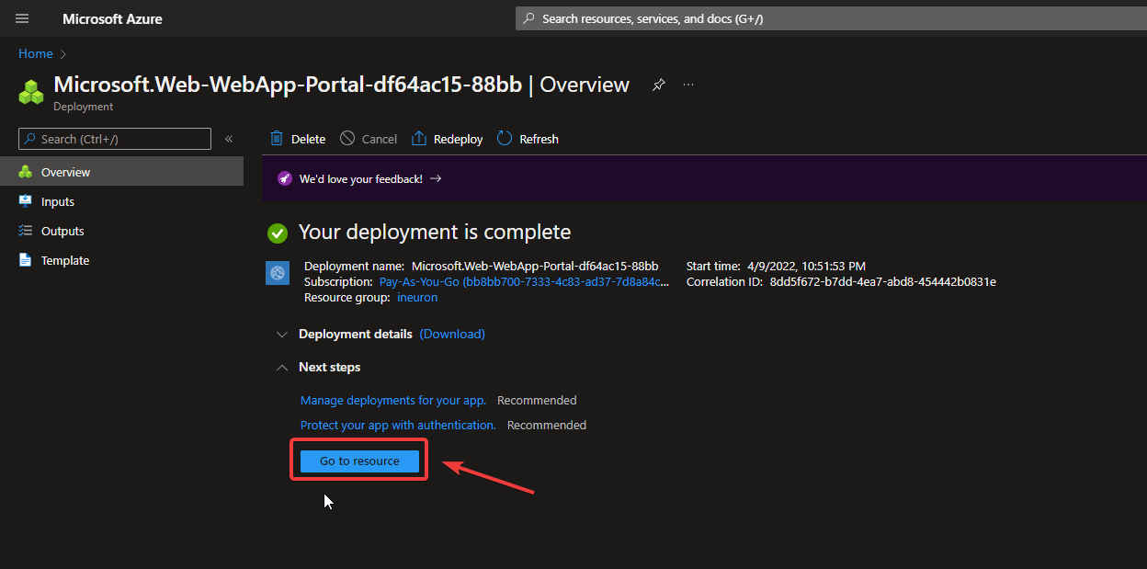

On the left-hand side, you’ll get the option ‘Deployment Center’.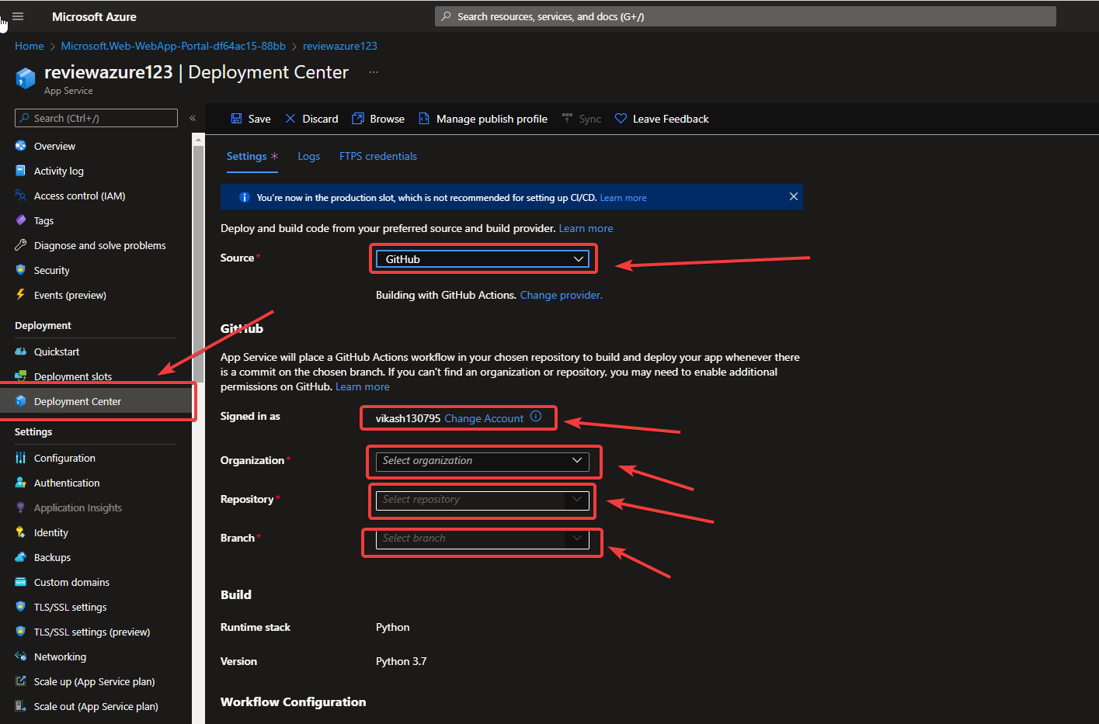

Select ‘GitHub’ in ‘Source’ option and add your github here. Then select your github repository and ‘Save’ it. It’ll start deploying your app.

Check-in your ‘Logs’, your app is in progress.

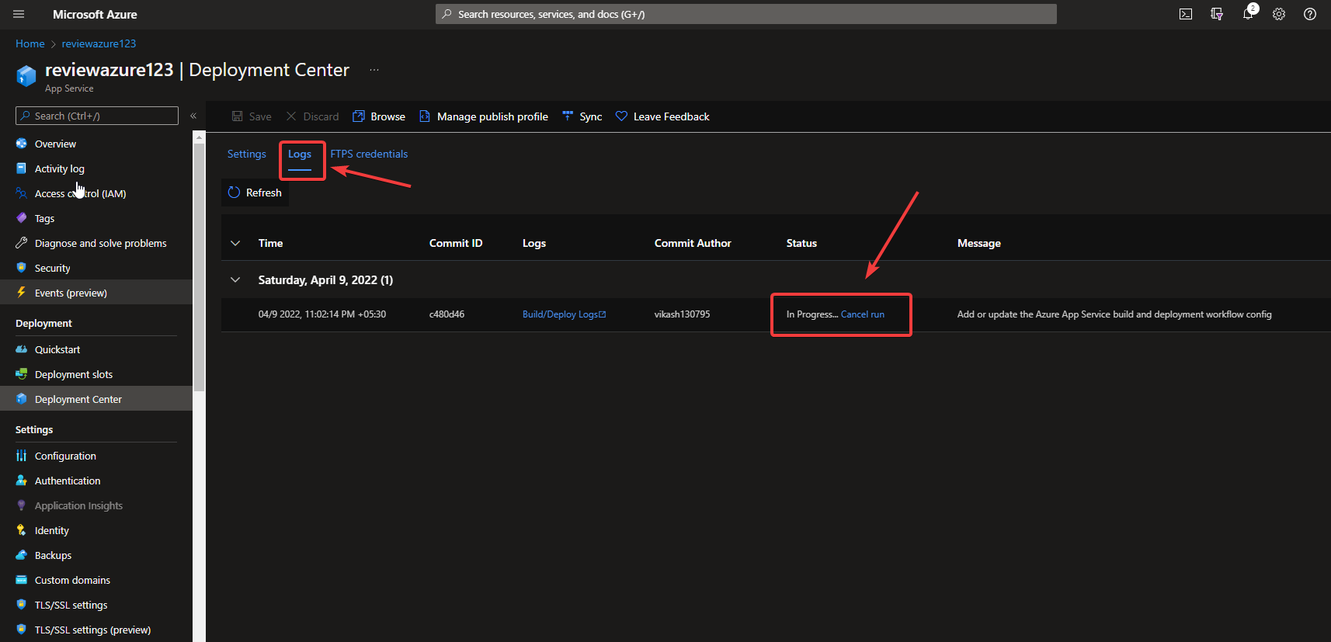

If deployment is done, you can browse your app through the ‘Browse’ button.

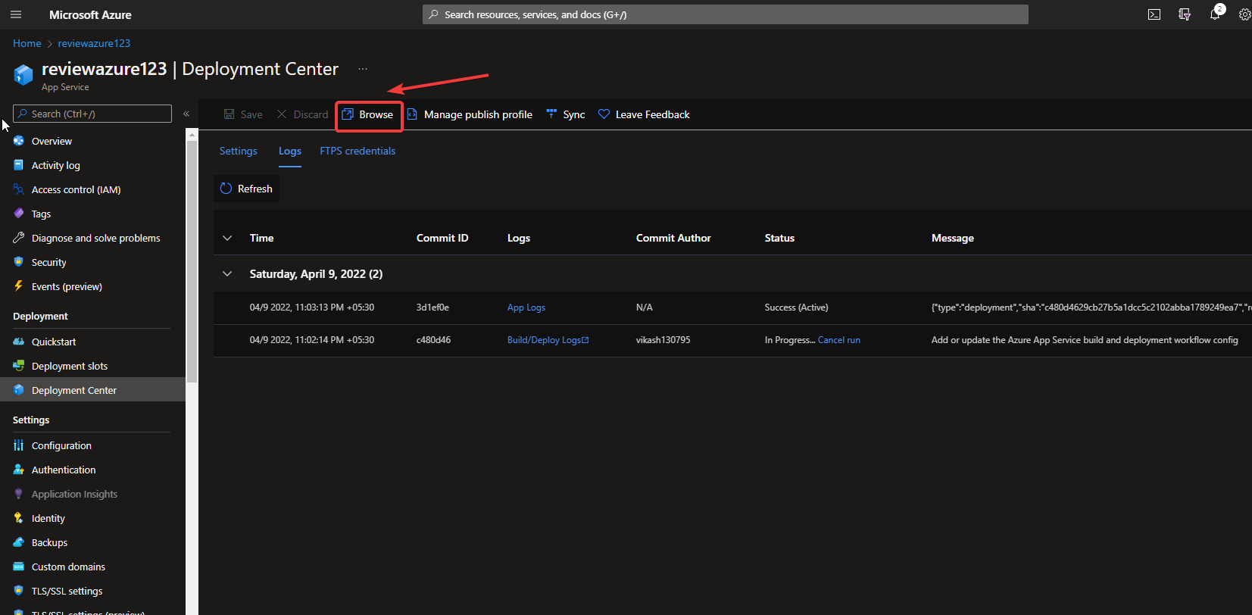

It was successfully deployed, check the below screenshot.

